Final Fixes for PrintAhead 2.0 (PayPal)

11.7.2016

* Some additional text on Set up screen. This text need to be hidden when Easter Egg is pressed (see point 7). – ***DONE!***
* Also, Child 3D head needs to be hooked back and load. – The child button is enabled. If something wrong with model – please send me a correct model, because I don’t have any childs models.

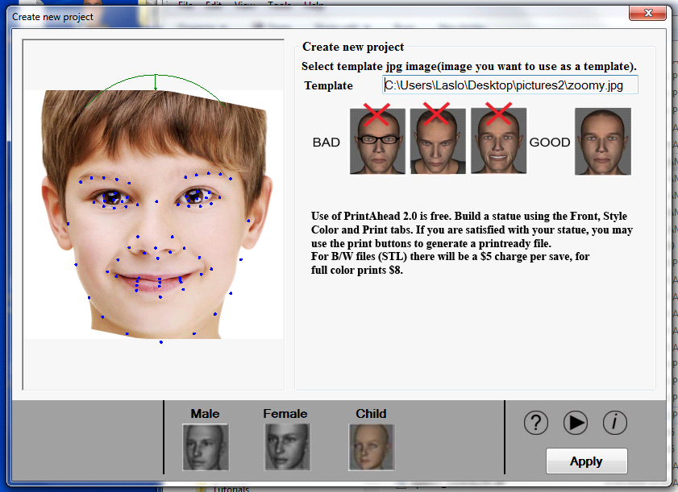

* The correct neck type needs to load (Male Base for Male, Female Base for Female and Child).

– ***DONE! When user open “Print” tab – base appears. It’s ok?***

Please eliminate Accessories Tab (not needed as we load the Male and Female base automatically). Also, add two buttons for toggle between Color and B/W (currently the space bar). – ***DONE!***

* When loading Hair the Neck disappears. Pls. fix. – ***DONE!***

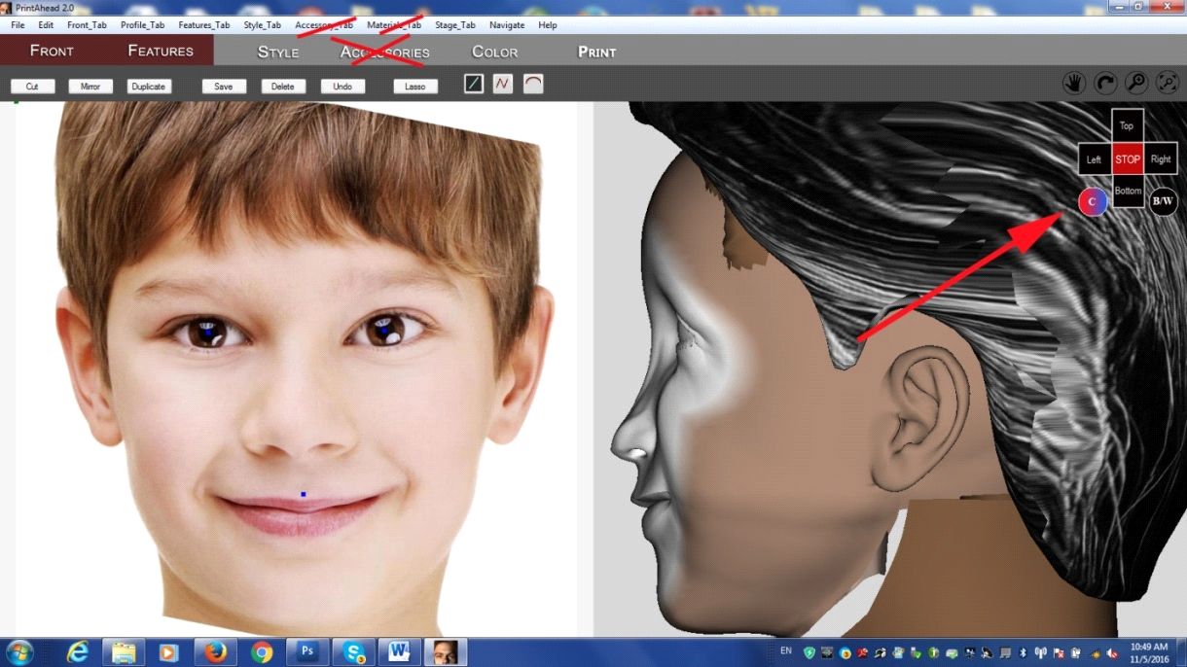

* Please add modified slider to Parts Library. The reason is that because headshapes change, the hair needs to be made to fit precisely. – ***DONE!***

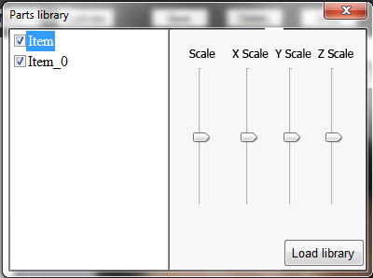

* Simplify Print screen. Mantel piece picture loads automatically. Notice that the dialog no longer has a choice of images and some buttons are also eliminated. The save Color Print button should only produce one file (the zip file). Zip file and STL file should bear the unique name given by the user. – ***DONE!***
* I also need an “Easter Egg” – some type of key stroke that will enable or disable the PayPal feature. The reason is that if I donate software for a school, they do not have to pay for the output. – ***DONE! In PrintAhead/bin folder you can find “rh_Saqr.dlib” this file. If this file exists – paypal will disabled. If you want to enable paypal – remove this file.***

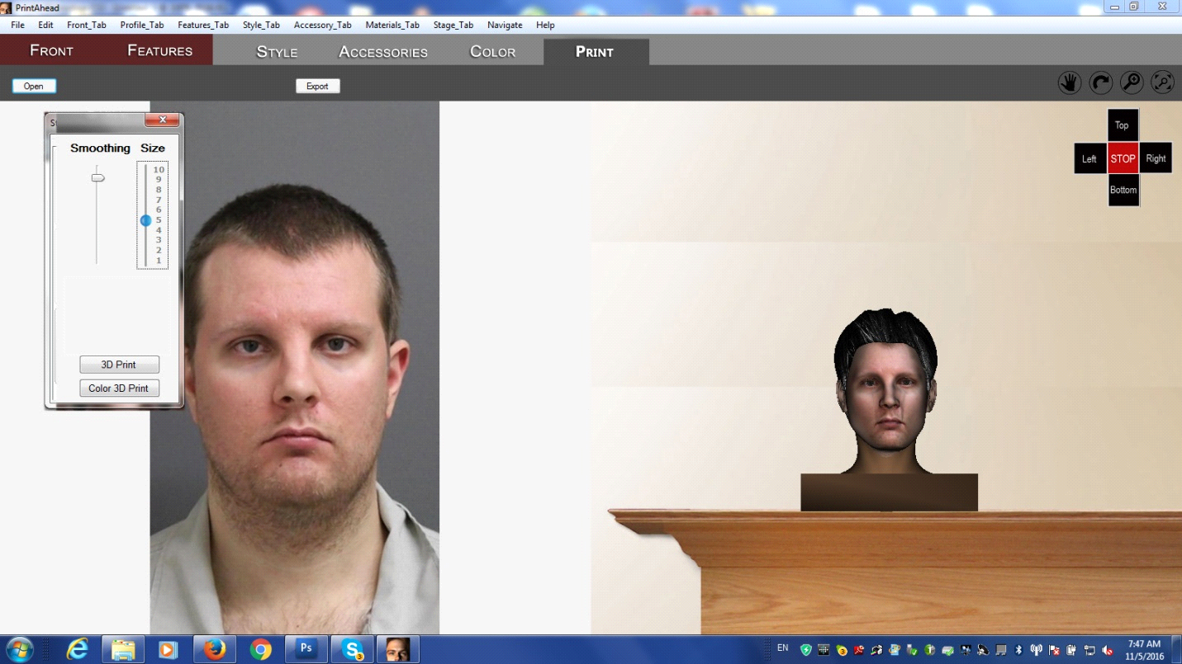

* 3D Print button not hooked up to PayPal yet. Color 3D print is OK. – ***DONE!***
* Scaling. I tested the Color 3D Print button and the scaling is off when it opens in Shapeways. For example: 5” setup scales up to 14.2”, the 3” scales to 10.5” and the 2” scales to 8.7”. It would be good to fix both outputs (zip and STL) to actually match real output size. – ***DONE!***
* No need to display abalone web page. – Not a good idea. I need to use this for correct work with paypal.

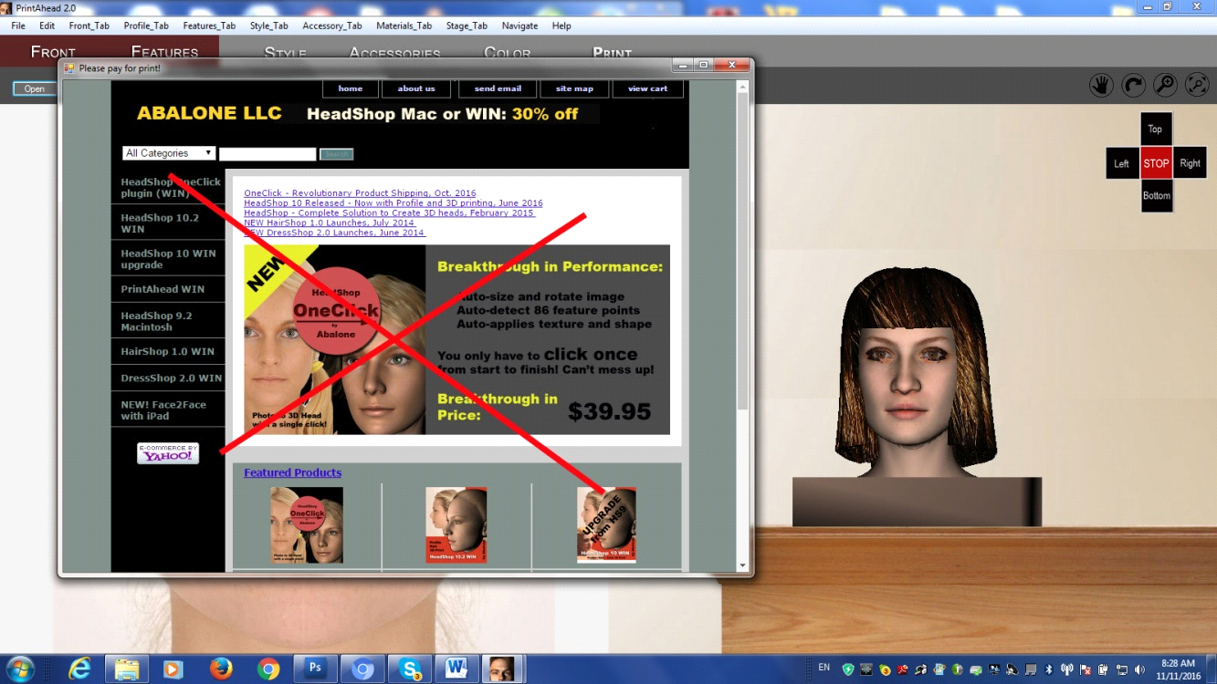

* It would be good if PrintAhead would create a PrintAhead named separate folder in ApprData/Abalone and not use the HeadShop folder. Currently HeadShop folder is compromised after each restart and need to be renamed. – ***DONE!***

If you remember, we use all libraries with hairs from common documents folder. You created one folder “headShop”. Now you should create two folder “PrintAhead” and “HeadShop”. And you can use different styles for different programs.

* SDK puts this dot wrong. Please ignore it and don’t translate to the model, – ***DONE!***

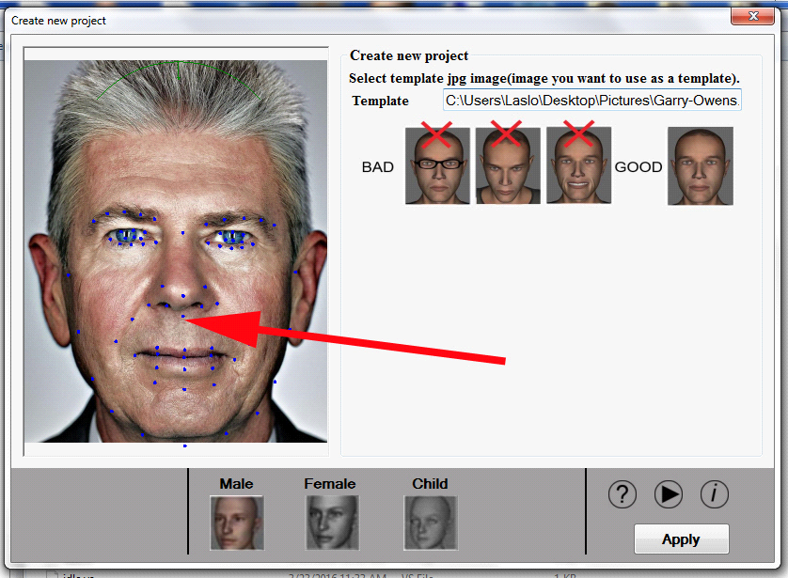

* The background color is still not good (earlier problem). It will show up very bad in printing. – ***DONE!***

Current condition

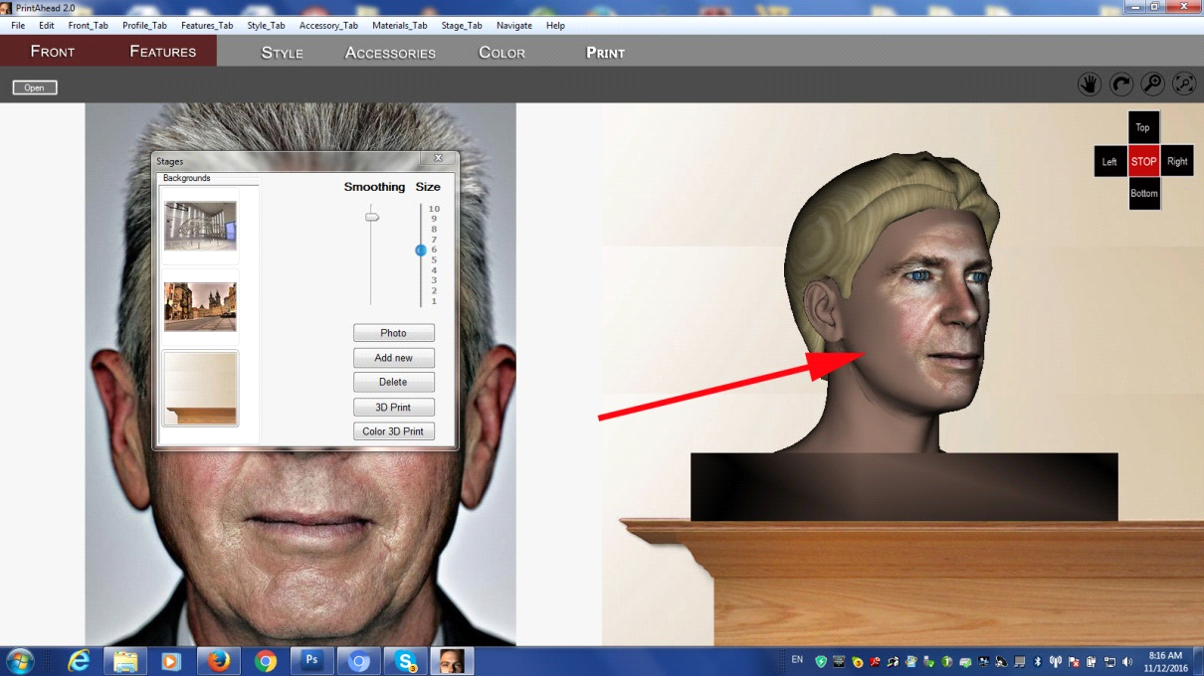

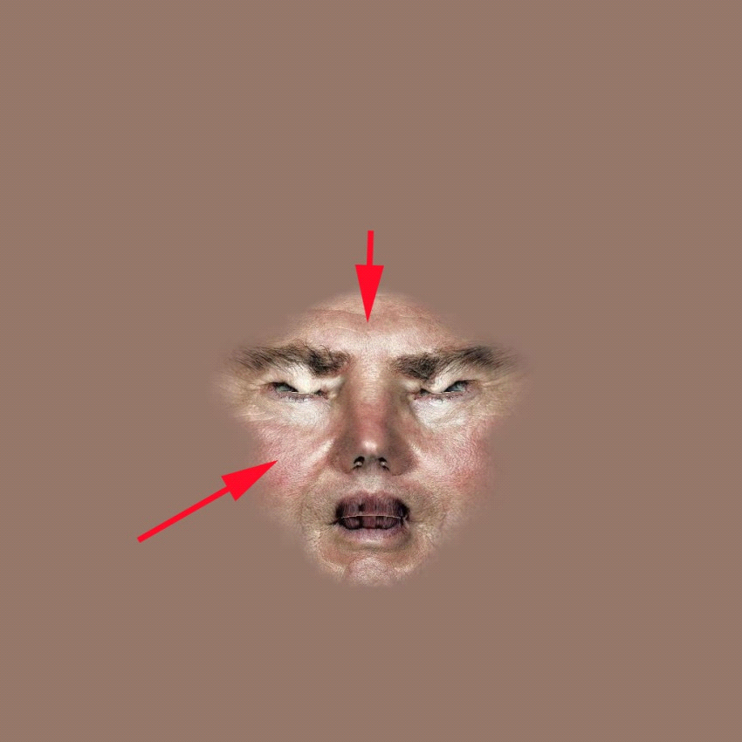

Desired condition

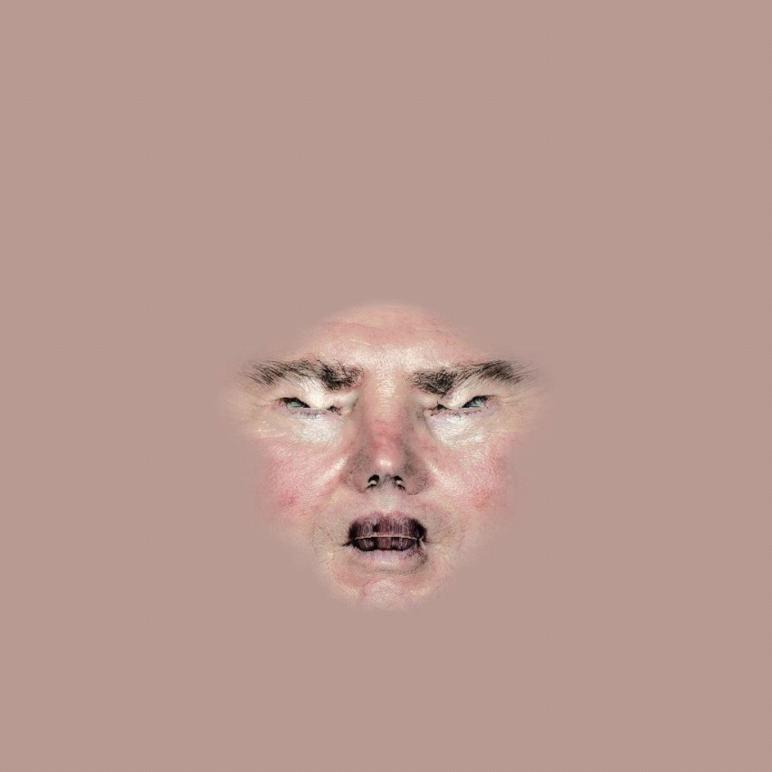

Maybe sample background color in points